BOTSWANA SIDE OF THE KALAGADI
We decided on a 3 week trip to this area staying on the Botswana side for 17 nights and only 1 on the South African side at Nossab. Below was our planned itinerary, we had done only the Mabu leg before.
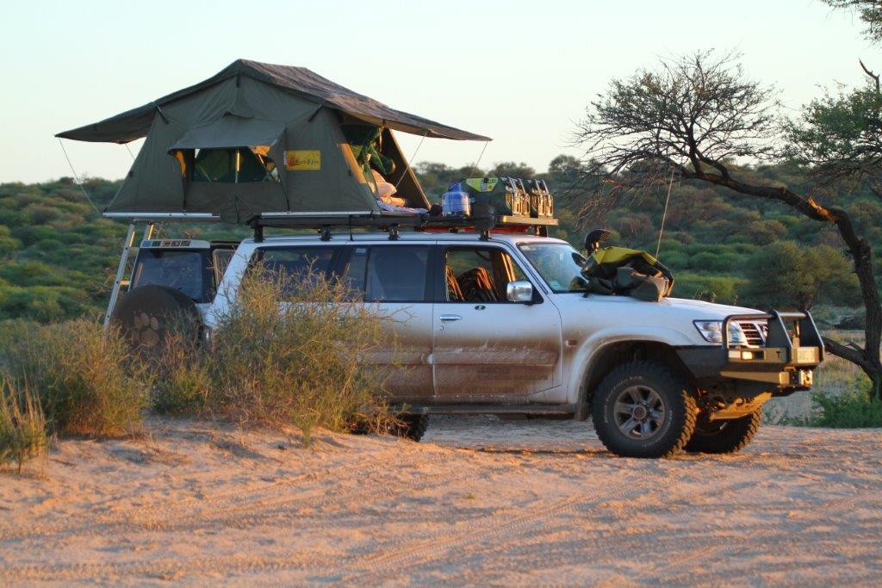
11-Apr | SAT | KURUMAN
12-Apr | SUN | MABU | mabu pan 4
13-Apr | MON | MABU | mabu pan 4
14-Apr | TUE | MABU | mabu pan 4
15-Apr | WED | MABU TRAIL | Mosaoane pan
16-Apr | THURS | NOSSAB | Nossab
17-Apr | FRI | POLENTSWA
 |  | GEMSBOK TRAIL | Sesatswe
18-Apr | SAT | GEMSBOK TRAIL | Langrambuta
19-Apr | SUN | KAA SIZWE PAN | Sizatsoe 1
20-Apr | MON | KAA SWARTPAN | Swart pan 1
21-Apr | TUE | KAA GNUS | Gnus 1
22-Apr | WED | KAA GNUS | Gnus 1
23-Apr | THURS | KAA THAPEDI | Thupapedi 1
24-Apr | FRI | KAA THAPEDI | Thupapedi 1
25-Apr | SAT | POLETSWA | Camp no 1
26-Apr | SUN | POLETSWA | Camp no 1
 |  | NOSSAB
27-Apr | MON | TWO RIVERS | Camp no 2
28-Apr | TUE | TWO RIVERS | Camp no 2
29-Apr | WED | TWO RIVERS | Camp no 2
30-Apr | THURS | KIMBERLY | Protea hotel
01-May | FRI | HOME
Travelling with our retired dairy farming friends in their Land cruiser we left early for Kuruman and decided to follow the back roads which was great until we hit a massive thunderstorm on the dirt road R372 from Rivilo,both vehicles were transformed into a red mess 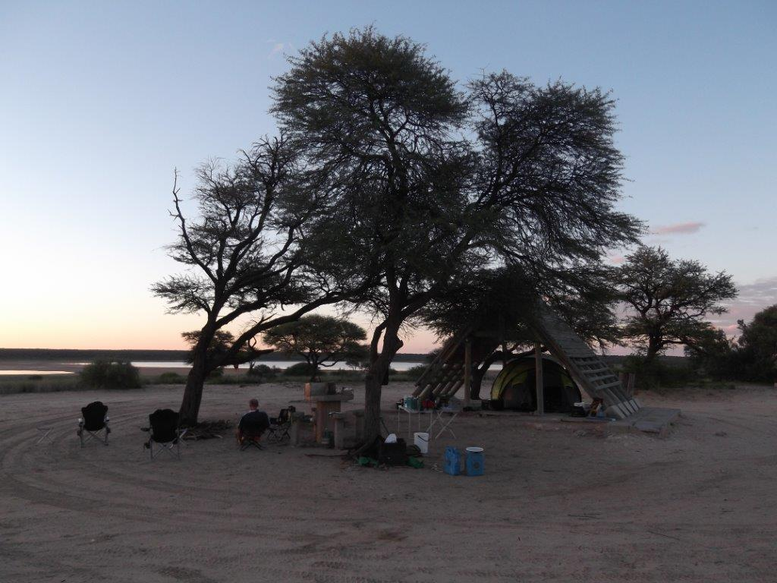
MABU CAMPSITE
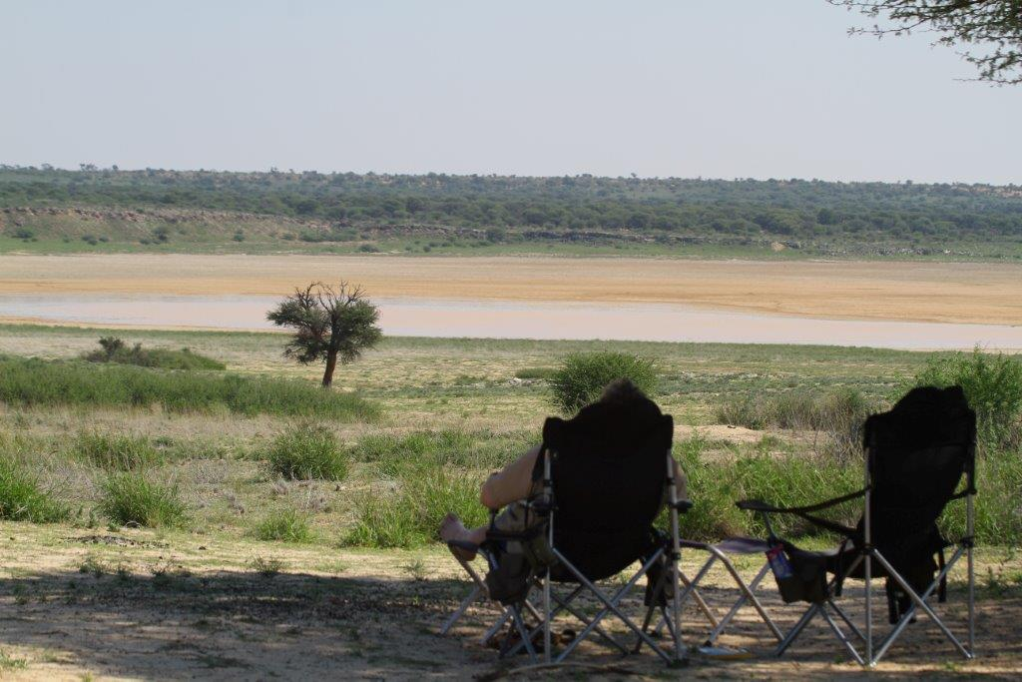.
The next day we set off for Mabu and had the most pleasant border crossing in years with polite and friendly staff on both sides. Mabu was green and the Mabu pan was full of water. We were visited by the notorious lions on our second night whist sleeping on the ground, it is one guaranteed way of getting cuddled by your wife!!! The game was not as numerous as during our last visits, just sitting camp overlooking the pan and reading was a great way to unwind. We have always made sure on our trips that the first campsite is a 3 day stay just to unwind before doing anything else.
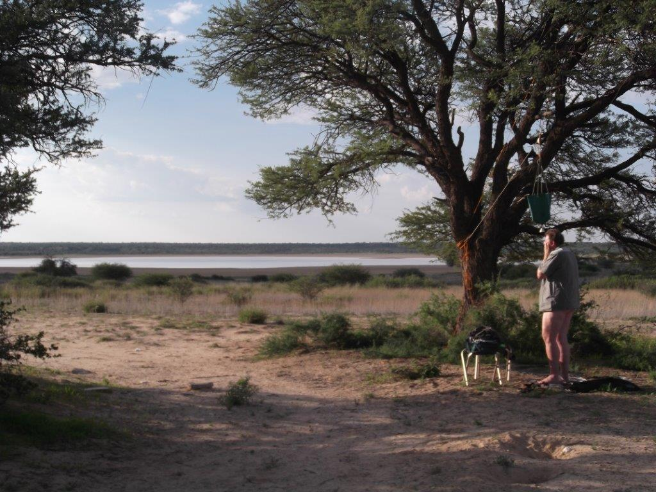
THE CLEAN UP
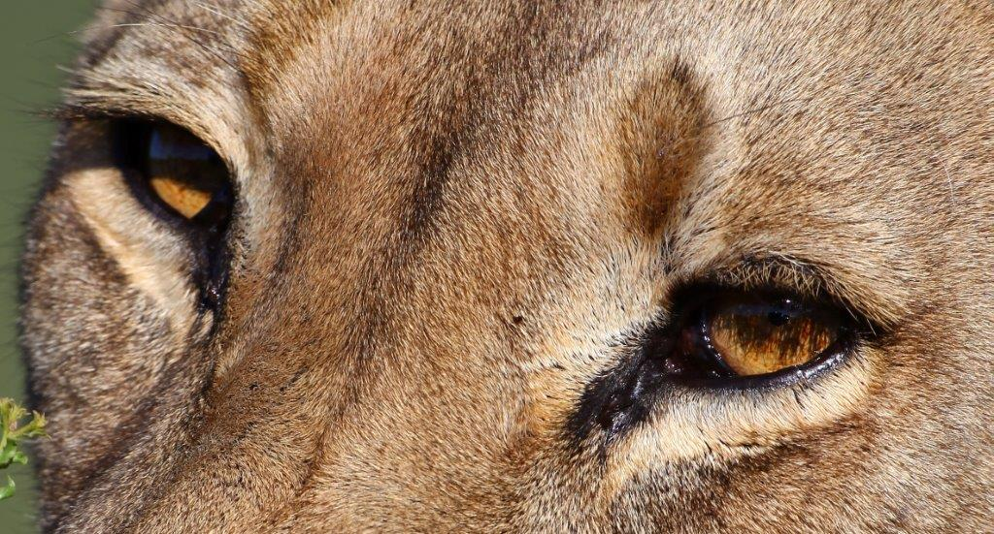
WHOS LOOKING

